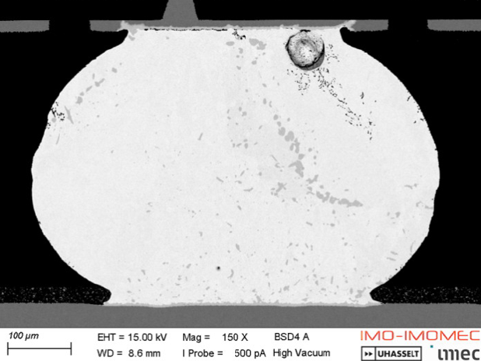

Building Better BGAs for High-Current, High-Performance Applications: Current densities for high-performance applications such as AI/ML (artificial intelligence/machine learning) have continued to increase to levels never seen before. The power consumption of modules in the advanced nodes used in these applications is starting to exceed 1 kilowatt, resulting in critical current values throughout the power-delivery path. Because many improvements already have been made to 1st-level interconnect structures (i.e., to copper pillars and to the “C4s” used in flip-chip interconnections), the 2nd-level interconnect – the ball grid arrays (BGAs) which connect packages to circuit boards – is now becoming the weakest link in power delivery, due to electromigration caused by high currents.
To learn how BGA performance can be improved, a collaboration team between Imec and Marvell conducted analyses of the current-carrying capability of BGAs under a variety of different conditions, taking into account substrate design, pad finishes and solder materials, and process variations. They will describe how they used thermal/electrical simulations to guide the design of their experiments, which validated their analyses. They say the work provides confidence that BGA solder ball design rules could be stretched up to 3 A per connection using optimized design and material combinations.

The image above shows the microstructure of a failing BGA solder connection under accelerated test conditions and reveals the failure mechanism of interfacial void growth due to electromigration.

(Paper #16.7, “BGA Electromigration Behavior and Why it has Become the Bottleneck,” R. Labie et al, IMEC/Marvell)

